**Note: Total (per bed) cost for components at retail prices listed below approximately $79.44 plus tax. Prices/products typically change with each shipment a store gets so this is just an approximation.**

**16 cu ft soil is needed for a 4ft x 4ft x 1ft deep bed. In the past, “16 cu ft” purchased components did not actually end up being 16 cu ft, so there is 2 cu ft extra added below for a total of “18 cu ft”. You may use extra, if there is any, to top dress as your bed settles.**

**Soil Mix for 4ft x 4ft x 1ft Deep Bed**

**1 1/2 bags = 6 cu ft vermiculite**

**$21.20 for a 4 cu ft bag at Farmers’ CoOp in Nashville**

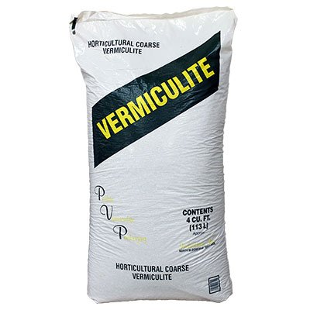

**1 compressed (3 cu ft) bale =**

**6 cu ft peat moss**

**$11.98 for a 3 cu ft compressed bag at Lowe’s in Texarkana, $14.25 at Farmers’ CoOp in Nashville;**

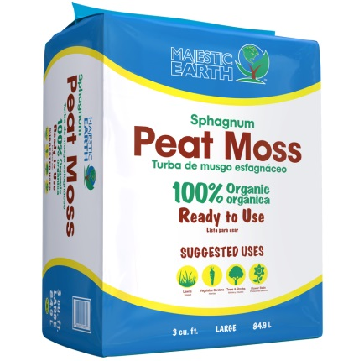

**3 bags = 3 cu ft compost**

**$5.97 per bag at Wal-Mart in Nashville; may be out now . . . (bought ours on clearance in Hope for $4 per bag)**

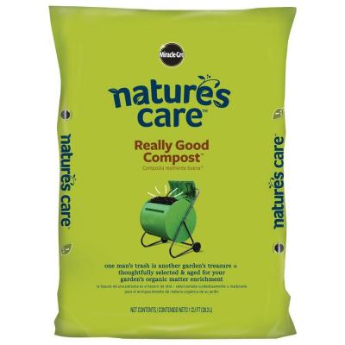

**2 bags = 2 cu ft compost**

**$6.49 per bag at Wal-Mart in Nashville; may be out now . . .**

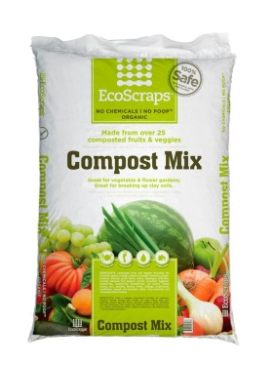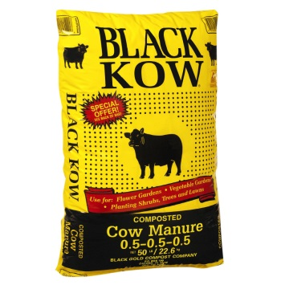

**1 bags = 1 cu ft compost**

**$4.77 per bag at Wal-Mart in Nashville; may be out now . . .**